8:00 – 8:30 – Welcome – Introductions – Google Earth - Where in the world would you like to go? Great tool.
- Name
- school
- position
- grade level
- Smart Board status
- goal for the day

8:30 – 8:50 – Use selector on SB. Teachers share ideas they have used.
8:50 – 9:10 – Practice with Name, word or group generators. (content related) Demo & Practice
9:10 – 9:25 – Insert Scrolling Banner – Demo & Practice
9:25 – 10:15 – Lesson Activity Toolkit – JOLLY
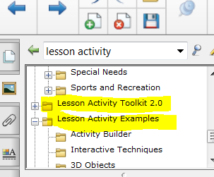
Each team goes through the toolkit and choses an item to demonstrate. -
10:15 – 10:30 – Break
10:30 – 11:00 – Finish up demo by teams of Lesson Activity Toolkit.
11:00 – 11:30 – Lesson Activity Toolkit Examples -
11:30 – 12:30 – Lunch – Please return promptly
12:30 – 1:00 – Demonstration – Gloria Shirley and iPad Mirroring/Sharing
1:00 – 1:15 – Questions – Sharing Ideas
12:30 – 1:00 – Color Reveal
1:00 – 1:30 – Practice Color Reveal
1:30 – 2:00 – Balloon Pop
2:00 – 2:30 - Work time – Get lessons or websites you want to use.
2:30 – 2:45 – Homework/ share out – 1 thing you are excited about!
2:45 – 3:00 - Questions, Evaluation Form – LATER GATOR!
Homework : Use MYUEN’s lesson plan tool to create a lesson that supports your Notebook file. Submit a Notebook file with at least 2 pages. This lesson plan and Notebook file should be appropriate for your grade level and be useful in your classroom. Submit both to me at
leslie.lewis@slcschools.org Deadline for this is October 31, 2014.
Your homework will be posted on the SLEDTECH website for other teachers to use.
Rubric includes but is not limited to – Locking, ordering, grouping, using items from the Lesson Activity Toolkit2, correct spelling, capitalization.
Please include your name in the filenames. Please give your Notebook File and Lesson Plan a title such as, 5th Grade Circuits or 6th Grade Solar System. That will give me an indication of where to put it on the website.
My UEN Account Info - Log in and Password _____________________________________________________

